

**User Guide**

|  |  |  |
| --- | --- | --- |
| **Faculty** | **Miss Neelam Malik** | |
| **Batch** | **2311B2** | |
| **Group** | **A** | |
| **Serial No.** | **Enrollment Number** | **Student Name** |
| 1. | Student1530073 | AMNA ATTARIA |
| 2. | Student1528816 | MARIA ALI |
| 3. | Student1531986 | LAIBA NASIR |

HOME PAGE!

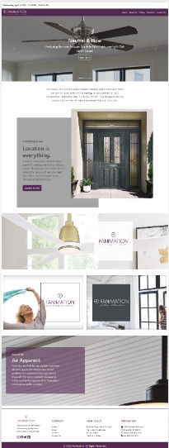

ABOUT US

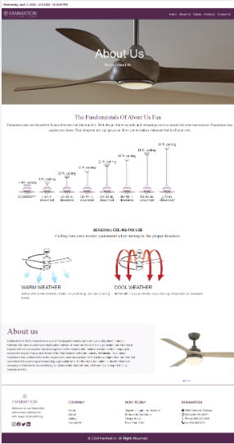

**TECHNOLOGY**

PRODUCT

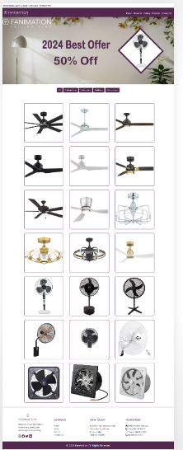

**ABOUT US**

**CONTACT US**

GALLERY

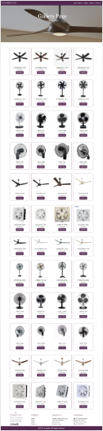

CONTACT US

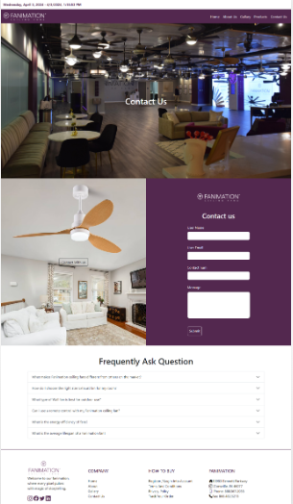

TASK SHEET REVIEW

|  |  |  |  |  |  |  |
| --- | --- | --- | --- | --- | --- | --- |
| Project Ref. No.: eP/Advertisement Portal Management System/01 | | Project  title | Date of Preparation of Activity Plan | | | |
| No | Task | Fanimation | Actual | Actual | Team-mate | Status |
| Start Date | Days | Names |
| 1 | Navbar | 15/MAR/  2024 | 1 | AMNA ATTARIA | Complete |
| 2 | Main Body Navbar | 15/MAR/  2024 | 1 | AMNA ATTARIA | Complete |
| 3 | Footer | 19/MAR/  2024 | 1 | MARIA ALI | Complete |
| 4 | Home Page | 20/MAR/  2024 | 3 | AMNA ATTARIA | Complete |
| 5 | Gallery | 05/APR  /2022 | 6 | LAIBA NASIR | Complete |
| 7 | Contact Us | 24/MAR/  2024 | 3 | AMNA ATTARIA | Complete |
| 8 | About Us | 1/APR/  2024 | 2 | MARIA ALI | Complete |
| 9 | Products | 05/APR/  2024 | 4 | MARIA ALI | Complete |